“My Name” from House on Mango Street by Sandra Cisneros
In English my name means hope. In Spanish it means too many letters. It means sadness, it means waiting. It is like the number nine. A muddy color. It is the Mexican records my father plays on Sunday mornings when he is shaving, songs like sobbing.
It was my great-grandmother's name and now it is mine. She was a horse woman too, born like me in the Chinese year of the horse--which is supposed to be bad luck if you're born female-but I think this is a Chinese lie because the Chinese, like the Mexicans, don't like their women strong.
My great-grandmother. I would've liked to have known her, a wild, horse of a woman, so wild she wouldn't marry. Until my great-grandfather threw a sack over her head and carried her off. Just like that, as if she were a fancy chandelier. That's the way he did it.
And the story goes she never forgave him. She looked out the window her whole life, the way so many women sit their sadness on an elbow. I wonder if she made the best with what she got or was she sorry because she couldn't be all the things she wanted to be. Esperanza. I have inherited her name, but I don't want to inherit her place by the window.
At school they say my name funny as if the syllables were made out of tin and hurt the roof of your mouth. But in Spanish my name is made out of a softer something, like silver, not quite as thick as sister's name Magdalena--which is uglier than mine. Magdalena who at least- -can come home and become Nenny. But I am always Esperanza. I would like to baptize myself under a new name, a name more like the real me, the one nobody sees. Esperanza as Lisandra or Maritza or Zeze the X. Yes. Something like Zeze the X will do.

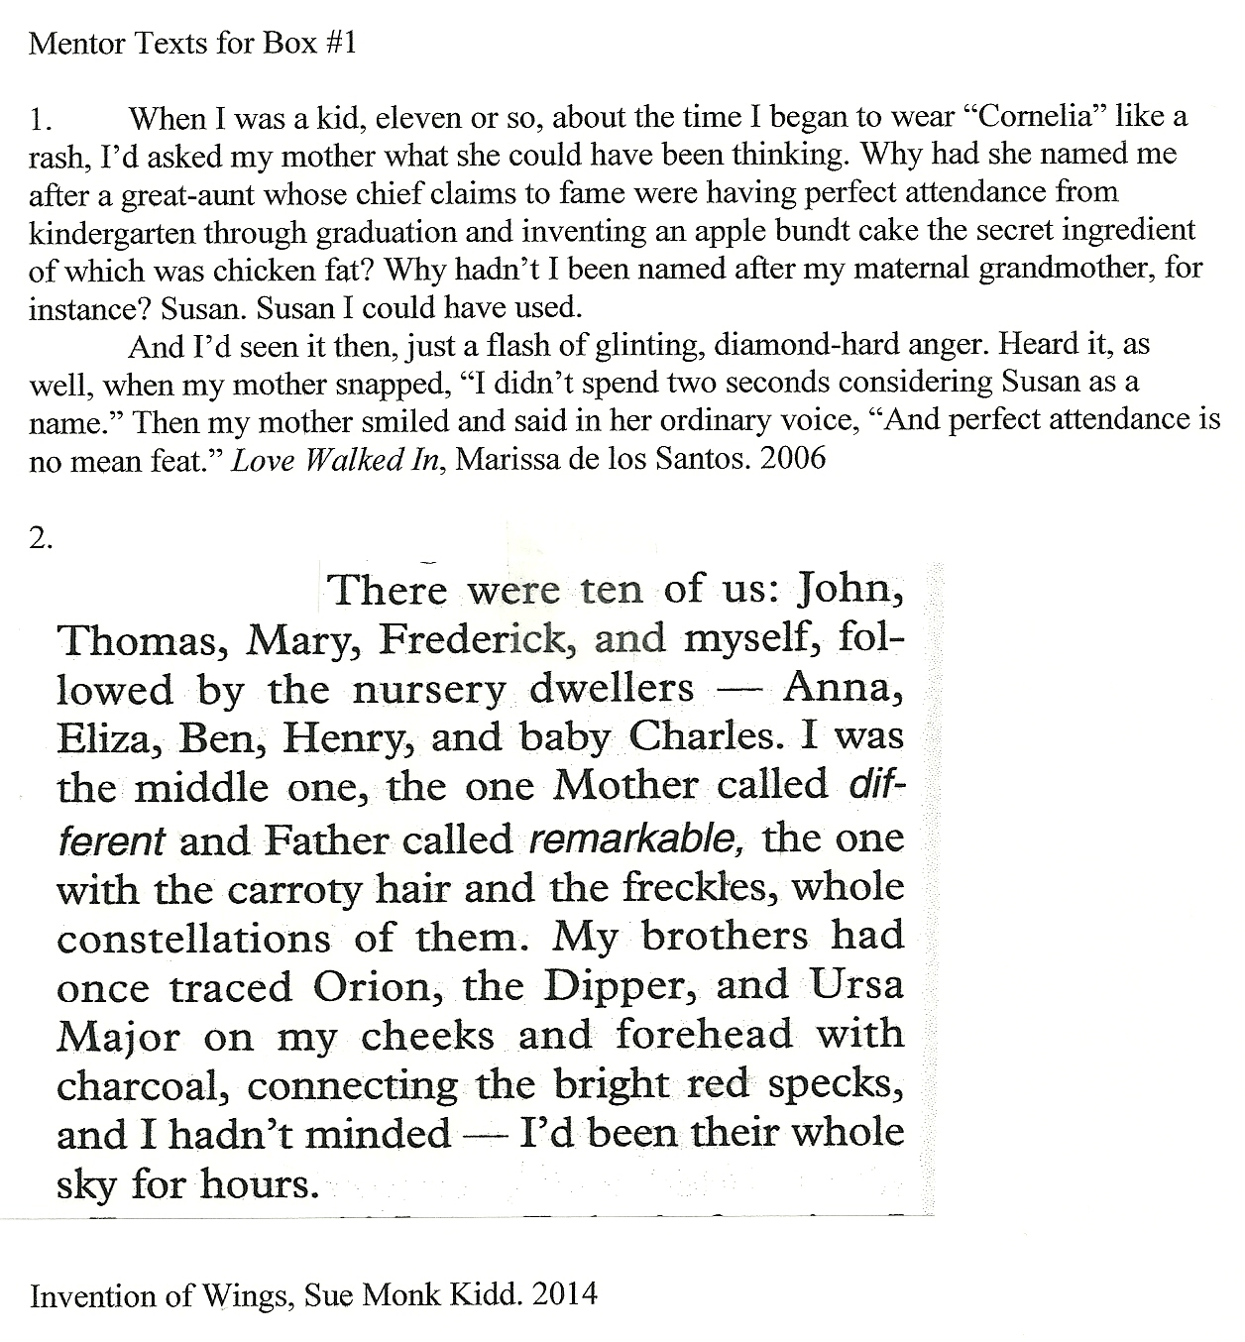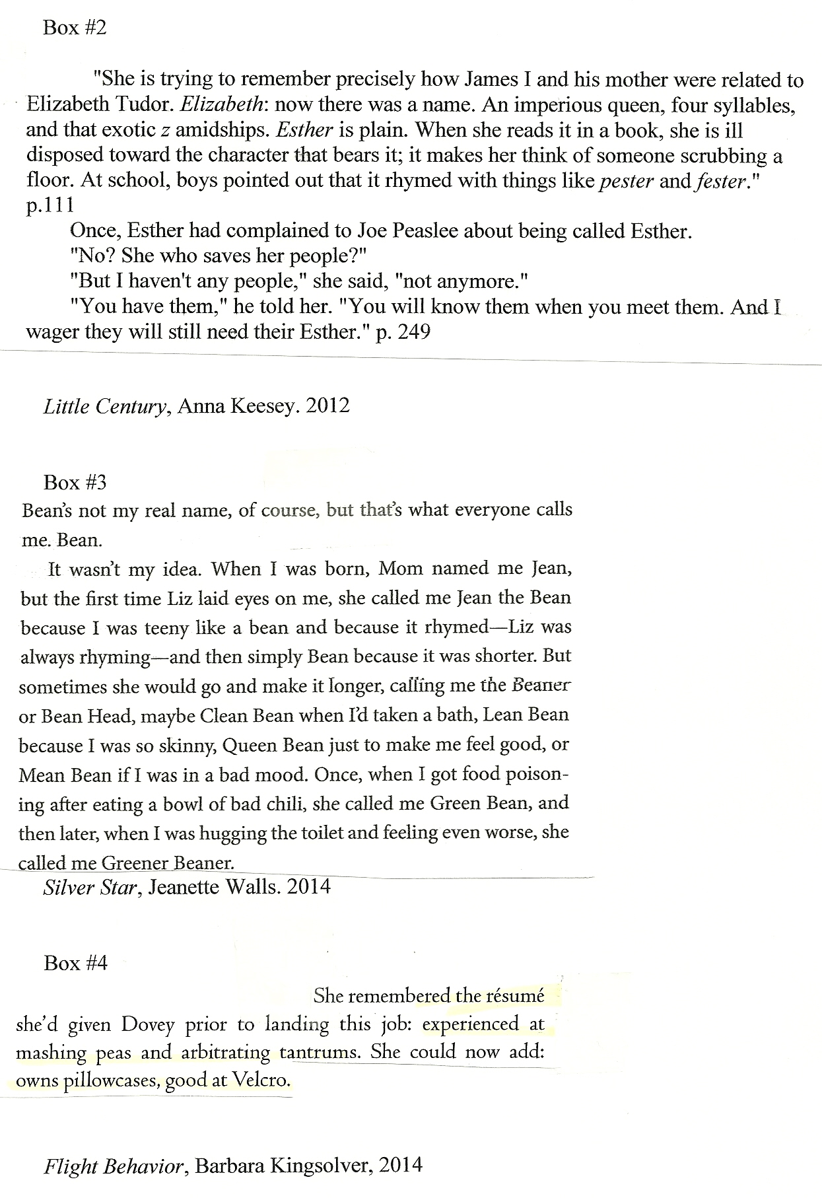
Mentor Texts to Use with “Name” Lesson

Flight Behavior--(everyday resume) Barbara Kingsolver
"She remembered the resume she'd given Dovey prior to landing this job: experienced at mashing peas and arbitrating tantrums. She could now add: owns pillowcases, good at Velcro."

Little Century--(family beliefs) Anna Keesay
"There was some agreement on what one valued and how one behaved. One believed in the progress of the workingman, in orchestras, in cleaning up the milk supply so poor children would not get sick. One went to see exhibitions of science and to flower shows, but could not afford opera and thought much of popular music maudlin....Everyone read more than one newspaper, and no one spit in the street, and if a child was born with a harelip, one sought and paid a surgeon."

Excerpt from All the Light We Cannot See, by Anthony Doerr. 2014.

Setting: coastal town in France, WWII.
Madame Manec, age 76
Marie-Laure, age 16

This very morning, she announces, she has managed to procure what might be the last two crates of peaches in France. She hums as she helps Marie-Laure with the peeler.
“Madame?”
“Yes, Marie.”
“What is a pseudonym?”
“It is a fake name, an alternative name.”
“If I were to have one, what sort of name could I choose?”
“Well,” says Madame Manec. She pits and quarters another peach. “You can be anything. You can be the Mermaid if you like. Or Daisy? Violet?”
“How about the Whelk? I think I would like to be the Whelk.”
“The Whelk. That is an excellent pseudonym.”
“And you, Madame? What would you like to be?”
“Me?” Madame Manec’s knife pauses. Crickets sing in the cellar. “I think I would like to be the Blade.”
“The Blade?”
“Yes.” The perfume of the peaches makes a bright ruddy cloud.
“The Blade?” repeats Marie-Laure. Then they both start laughing.

